Ankita Durgude

SQL Exercise 4

1. **Display the minimum Status in the Supplier table. Ans:** select min(Status) as 'minimum Status'from supplier;

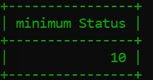

1. **Display the maximum Weight in the Parts table. Ans:** select max(Weight) as 'maximum Weight' from Parts;

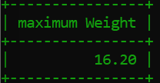

1. **Display the average Weight of the Parts.**

**Ans:** select avg(Weight) as 'average Weight' from Parts;

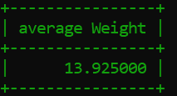

1. **Display the total Quantity sold for part ‘P1’. Ans:** SELECT `P#`,

-> SUM(qty) AS `Total Quantity Sold`

-> FROM `supplier-parts-project`

-> WHERE `P#` = 'P1'

-> GROUP BY `P#`;

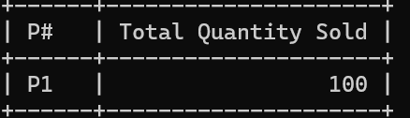

1. **Display the total Quantity sold for each part. Ans:** select `P#`,

-> sum(qty) as' Total Quantity sold'

-> from `supplier-parts-project`

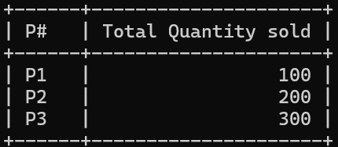-> group by `P#`;

1. **Display the average Quantity sold for each part.**

**Ans:** select `P#` as 'Part Number', avg(qty) as 'Average quantity sold' from `supplier-parts- project` group by `P#`

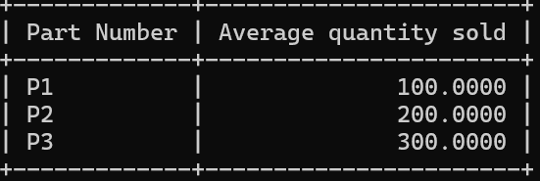

1. **Display the maximum Quantity sold for each part, provided the maximum Quantity is greater than 800.**

Ans: SELECT `P#` AS Part_Number,

-> MAX(qty) AS Maximum_Quantity_Sold

-> FROM `supplier-parts-project`

-> GROUP BY `P#`

-> HAVING MAX(qty) > 800;



1. **Display the Status and the count of Suppliers with that Status.**

**Ans:** select status, count(*) as 'supplier count' from supplier group by status;

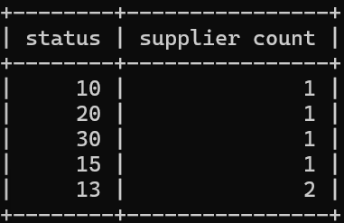

1. **Display the count of Projects going on in different cities.**

**Ans:** select city, count(city) as 'count of project' from projects group by city;

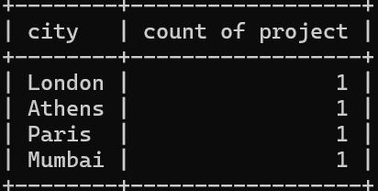

1. **What is the difference between COUNT(Status) and COUNT(*) ? Ans:**
2. **Display the Status and the Count of Suppliers with that Status in the following format**

as shown below:- Status

Ten Count 1

Twenty 2 Thirty

3

Ans: select

-> case

-> when status =10 then 'Ten'

-> when status = 20 then 'twenty'

-> when status = 30 then 'thirty'

-> else 'other'

-> end as 'status',

-> count(*) as 'count'

-> from supplier

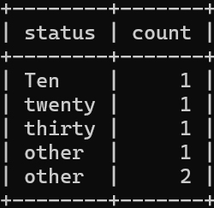-> group by status;